TEMPLATES STEP 1. MARKET SEGMENTATION

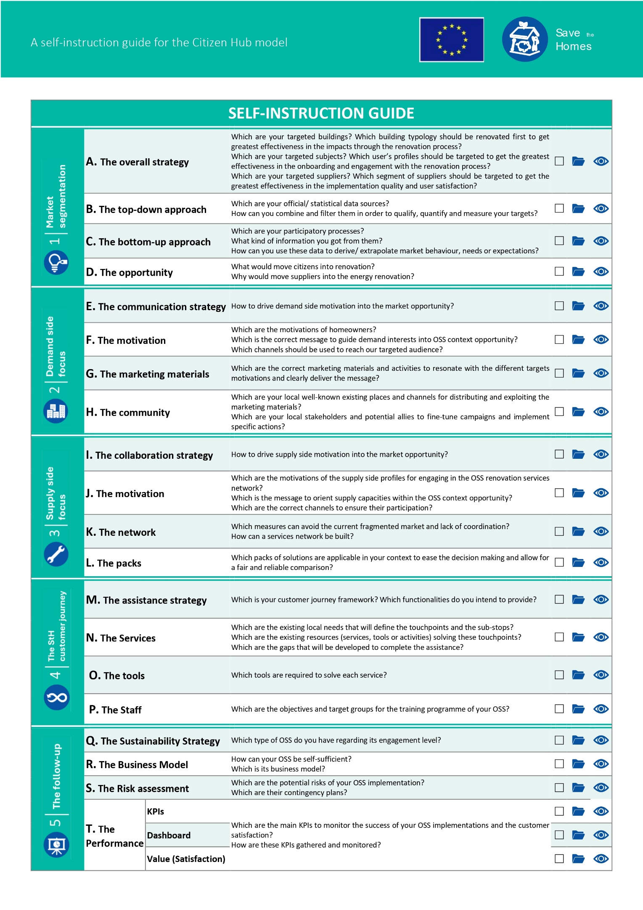
Figure 1. Test materials for step 1
This step (and its sub-steps) aims to map demand and supply side of your renovation market as a first step to design an OSS service in your context and implement your own Citizen Hub. Additional information is available in D2.1. Demand & supply side mapping: Methodology & results from the 2 pilots and its corresponding spreadsheet.

A. Presentation
Before starting this journey, present yourself and your friends:
Organization | Activity | Geographical scope | Contact

B. Objectives
Now, draft the main objectives pursued through the implementation of the OSS concept. This is important to orientate the search below.
- My first objective is to ____________________________________________________________
- Also, I would like to ______________________________________________________________
- And, if possible, I would also address ________________________________________________

C. Study area
Do you already have a physical office in place?
YES define geographical area around it:
- ________ meters from the office
- Districts: [names, codes]
- The whole city: [name, code]
NO define the wider geographical area under your scope (e.g., city):
- Districts: [name, code]
- The whole city: [name, code]
- The whole region: [name, code]

D. Mapping

D.1. Object (buildings)
The objective for mapping and segment buildings is to get the greatest effectiveness in the impacts achieved through the renovation process.
First collect information about your building stock context (regulations, history, grants schemes, bureaucracy, or other programs related to buildings):
________________________________________________________________________________________________________________________________________________________________________________________________________________________________________________________________________________________________________________________________________
Then select your characterization criteria:
- component approach for step-by-step renovation replicability
- morphology approach for integral renovation replicability
And list the attributes related to previous approach that you would need to analyse:
Attribute | availability | thresholds/ categories | source | format | granularity | date | comments

Now is time to mix, overlap, cluster: define your typologies, keeping in mind which context circumstances or potential impact related to your approach are interesting for you:
Typology | Attribute (interval) | Attribute (interval) | Attribute (interval) | Attribute (interval) | Attribute (interval) | Solution COMPLEXITY | comments

And finally, you need to quantify (& locate):
Typology | Area/ District/ City | Area/ District/ City | Area/ District/ City | City | Rate | IMPACT | comments
Number
Rate
According to previous data, select your target zones and typologies (quick wins for short term, targets for long-term):
- Quick wins: _____________________________________________________________________
- Typologies: _____________________________________________________________________
- Zones: _________________________________________________________________________

D.2. Subject (citizens, owners, occupants…)
The objective for mapping and segment people is to get the greatest effectiveness in the onboarding, involving and engagement with the renovation process.
We follow here the same structure than for mapping buildings but related to the people living or owning those buildings (previously targeted).
First collect information about your demographic context (regulations, history, habits, traditions, problems…):
______________________________________________________________________________________________________________________________________________________________________________________________________________________________________________________
Then select your characterization criteria:
- Economic approach, for affordability
- Social approach, for motivation
- Organizational approach, for simplification
And list the attributes related to previous approach that you would need to analyse:
Attribute | availability | thresholds/ categories | source | format | granularity | date | comments

Now is time to mix, overlap, cluster: define your profiles, keeping in mind which context circumstances or potential drivers related to your approach are interesting for you:
Profile | Attribute (interval) | Attribute (interval) | Attribute (interval) | Attribute (interval) | Attribute (interval) | Solution COMPLEXITY | comments

And finally, you need to quantify (& locate):
Profile | Area/ District/ City | Area/ District/ City | Area/ District/ City | City | Rate | IMPACT | comments
Number
Rate
According to previous data, select your target profiles (quick wins for short term, targets for long-term):
- Quick wins: _____________________________________________________________________
- Target Profiles: __________________________________________________________________

D. 3. Means (products, services, tools…)
The objective for mapping and segment suppliers is to get the greatest effectiveness in the implementation quality and user satisfaction through the renovation process.
Now you know which buildings you want to address (for replicability) and who you will need to approach (for engagement) in order to trigger an effective and efficient renovation path. So you just need to find out how feasible and reliable those renovations are.
We follow here the same structure than for mapping buildings and citizens but related to the people and companies providing services and solutions for them (previously targeted).
First collect information about your construction sector context (regulations, history, market, business, traditions, problems…):
________________________________________________________________________________________________________________________________________________________________________________________________________________________________________________________________________________________________________________________________________
Then select your characterization criteria:
- Process approach, for accompanying and providing customed solutions (based on the strategies to be defined from the buildings’ typologies analysis). This approach is much related with the morphological approach for building characterization, intended for a full deep renovation.
- Solution approach, for providing specific products and/or services to be defined from the buildings’ typologies analysis. This approach is much related with the components approach for building characterization, intended for a step-by-step renovation.
And list the attributes related to previous approach that you would need to analyse:
Attribute | availability | thresholds/ categories | source | format | granularity | date | comments

Now is time to mix, overlap, cluster: define your supplier’s profiles, keeping in mind which context circumstances or benefits related to your approach are interesting for you:
Profile | Attribute (interval) | Attribute (interval) | Attribute (interval) | Attribute (interval) | Attribute (interval) | Solution COMPLEXITY | comments

And finally, you need to quantify (& locate):
Profile | Area/ District/ City | Area/ District/ City | Area/ District/ City | City | Rate | IMPACT | comments
Number
Rate

According to previous data, select your target profiles (quick wins for short term, targets for long-term):
- Quick wins: _____________________________________________________________________
- Suppliers’ Profiles: ________________________________________________________________

E. Summary
This last step consists of putting everything together to have a better overview:
Area/ District/ City | Area (Km2) | Dwellings (buildings) | Population (households) | Contractors | Building Typology (n) | Demand profile (n) | Supplier profile (n)
 |  |  |  |  | To Solutions | To community | To network

