TEMPLATES STEP 2. DEMAND SIDE FOCUS

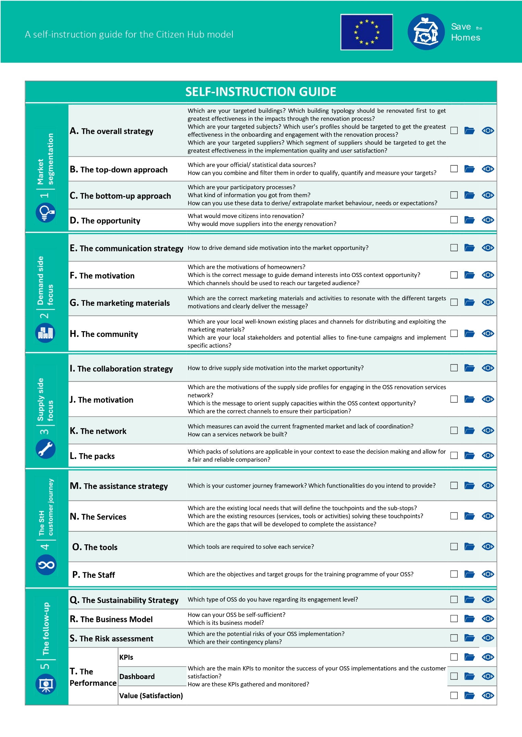
Figure 1. Test materials for step 2
This step (and its sub-steps) aims to design a proper long-term communication strategy and build an involved and durable stakeholders’ community. The document required to define your local context demand side needs, which involves the four sub-steps (from E to H), is available in D2.2. Guideline for long-term citizen engagement.

Introduction
The objective is to design a communication strategy for the demand side profiles, by detecting potential opportunities to on-board, appropriate messages and best fitting channels, to get them to the Citizen Hub and their most suitable renovation path. This is to be done without losing sight of the design of adapted marketing materials and training programs.

Needs, motivations & barriers
Before starting this journey, have your Mapping tables at hand.

A.1. Targeted Buildings
The objective of defining building typologies is to get the greatest effectiveness in the definition of targeted buildings intervention categories.
Think of the data sources available at your context level in order to know better your buildings weaknesses and potential solutions (such as mandatory reports or certificates which might be analysed in order to extract information):
________________________________________________________________________________________________________________________________________________________________________________________________________________________________________________________________________________________________________________________________________________________________
Now, for each of your targeted building typologies, note the component (façade, roof, heating system…) on which you could more easily act to improve its energy performance, and the solution type you would propose (change into…, addition of…)
Building typology | Component | Solution type

Not forgetting a potential step by step approach for going from a single measure implementation to a deep retrofitting. Select the most suitable strategies in your context:
- Low maintenance
- Ecology
- Economical
- Passive house
- Lifespan
- Comfort
- Low energy consumption
- Integral
- All-electric
- Other: _____________________________________

A.2. Targeted population
The objective of defining personas is to get the greatest effectiveness in the definition of targeted population wishes and possibilities.

Think of the data sources available at your context level in order to know better your citizen motivations and opportunities to on-board on the renovation process (such as administration surveys or scientific studies):
________________________________________________________________________________________________________________________________________________________________________________________________________________________________________________________________________________________________________________________________________________________________

Now, for each of your targeted demand profiles, note the motivations (necessity, pleasure, step-up…), opportunities (existing problems, grants…), objectives (renovation, replication, dissemination…), drivers (status, access, power, stuff) and opportunities of success (very low to very high):
Demand profile | Motivation | Opportunities | Objective | Driver | Success?

Campaign strategy design

B.1. Targeted Buildings
The objective of defining a building typology itinerary is to get the greatest impact from the communication strategy messages and channels.
According to the itineraries’ strategy adopted for this step, we start defining the communication strategy structure related to each building stock categories. For each of your building typologies, define the opportunity to renovate (an attribute that clearly leads to a potential intervention), the message or approach and the channel (things or allies delivering the message). Be aware that they can be more than one:

Building typology | Opportunity | Message | Channel

B.2. Targeted Population
The objective of defining a demand profile itinerary is to get the greatest effectiveness in the definition of the communication strategy messages and channels.
According to the itineraries’ strategy adopted for this step, we start defining the communication strategy structure related to the demand side profiles. For each of your demand profiles, define the opportunity to renovate (a moment or action that clearly leads to a potential intervention), the message or approach and the channel (things or allies delivering the message). Be aware that they can be more than one:
Demand profile | Opportunity | Message | Channel

Community Building
According to the itineraries’ strategy adopted for this step, we need to get to the previously detected stakeholders and potential allies, that would be contacted in order to fine-tune campaigns and implement specific actions.

C.1. Targeted stakeholders
The objective of building a Demand side –Advisory Board is to get the greatest closeness to the local context from the personas/ profiles’ descriptions (fine-tunning) and implement better communication campaigns.
First part of this section is to involve local organizations in touch with targeted population, which have expertise in dealing and communicating with them. On the other hand, community leaders, public figures as well as local "grass roots" organizations that are motivated to support energy efficiency for its public benefits, including economic well-being of community members, and community carbon mitigation goals are included to promote the renovation initiatives. Therefore, the Sav€ the Homes Advisory Boards (StHAB) have a pivotal role in establishing sustainable networks to support the local eco-systems.
Think of your natural allies already detected in the Mapping activity and those who have arisen while thinking on potential channels to deliver your messages. Define their adscription (public or private), their team (grouping entities performing the same king of activities, such as condominium, consumers’ association…), and objective for contacting them (refine communication strategy, disseminate…):

Entity | Public/ Private | Team | Objective

Summary
As a conclusion, all the detected messages and channels, are to be translated into allies, resources, products and services, and put together so to understand the next activities needed to perform, the contacts to be made, and the channels and relations to get, in the pilot field activities:
Messages & channels
Offered by the Citizen Hub |  | Citizen hub orbit
Content | Strategy | External Resources | Allies
To customer journey & business model |  | To Solutions | To Contacts (AB) and campaigns

