TEMPLATES STEP 3. SUPPLY SIDE FOCUS

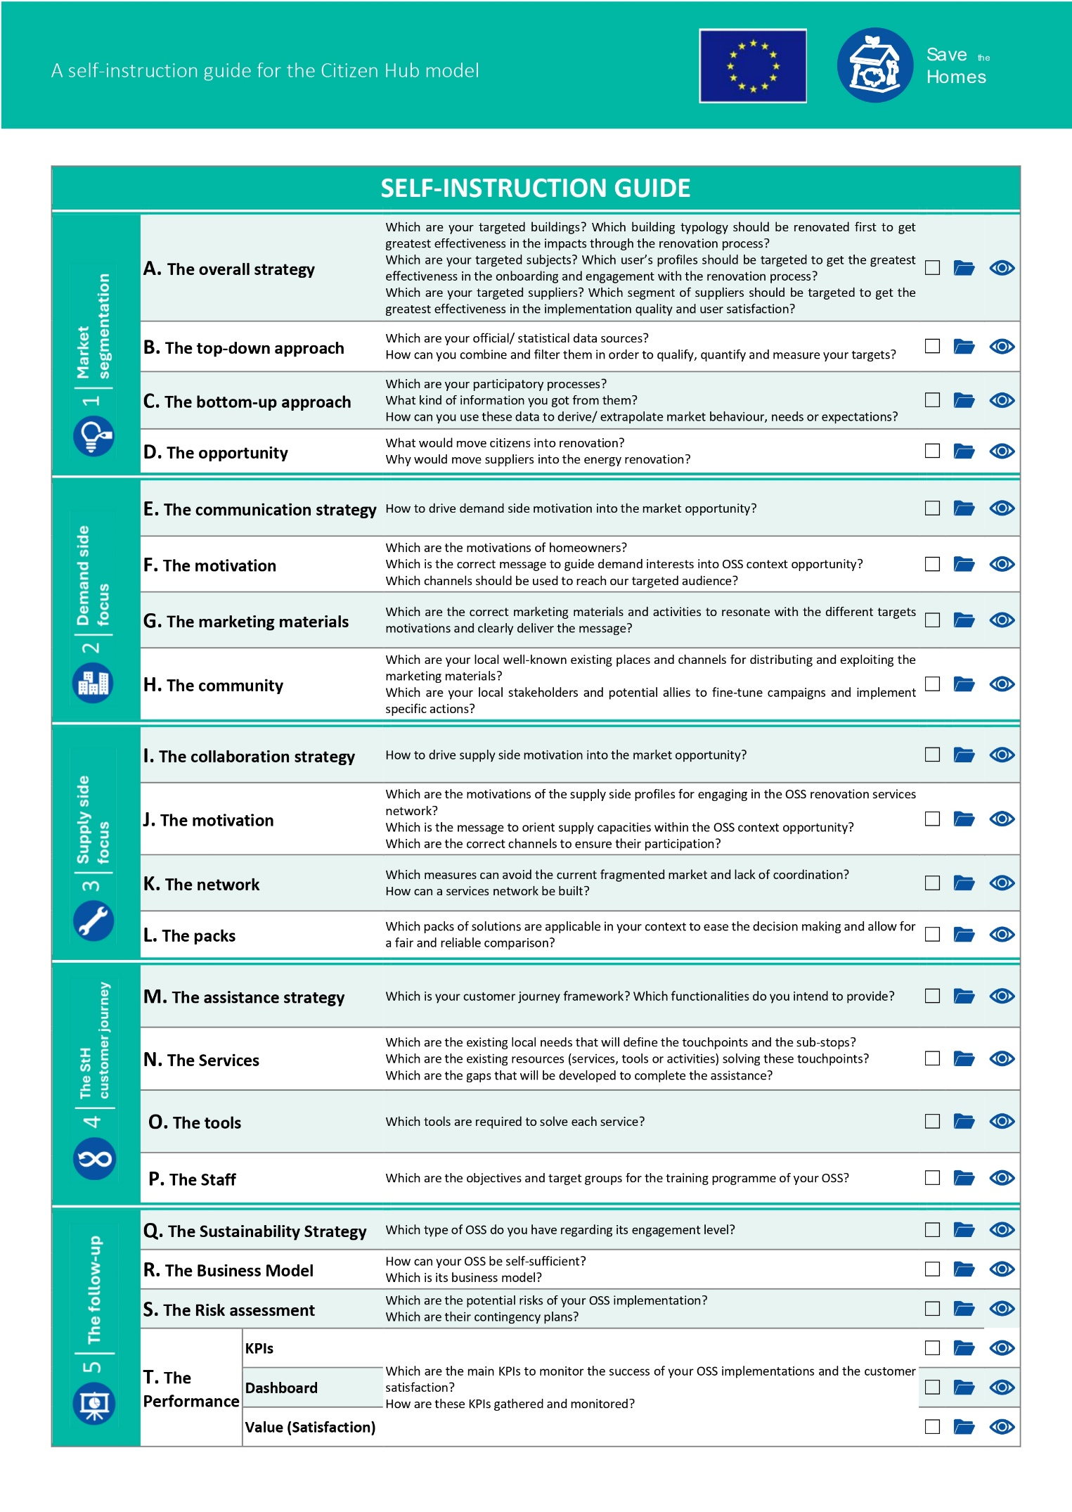
Figure 1. Test materials for step 3
This step (and its sub-steps) aims to define your local context supply side offer in order to design a proper long-term collaboration strategy and build an involved, durable stakeholders’ network.
- For sub-steps I to K, additional information is available in D2.3.- Citizen Hub protocol for supply side community building and network creation. These steps are included in the section 3.1. Supply side involvement.
- For sub-step L. The packs, additional information is available in D2.5. Suitable renovation packages and supporting services for the two pilots. This step is included in the section Step 3.2. Offer design.

STEP 3.1.- SUPPLY SIDE INVOLVEMENT

Introduction
The objective is to design a collaboration strategy for the supply side profiles, by detecting potential opportunities to on-board, appropriate messages and best fitting channels, to get them to the Citizen Hub and find their most profitable renovation offer presentation. This is to be done without losing sight of the design of appropriate validation mechanisms and training programs.

Activities, size & roles
Before starting this journey, have your Mapping tables at hand.
The objective of defining supply side profiles is to design optimal and reliable offers improving trust and awareness of homeowners, reducing renovation decision making processes’ costs and time, and mainstreaming innovative technical solutions adapted to the local context.
First of all, think of the purpose of your profiling:
- Is it for better offer the selected technical solutions?
- Is it for better design affordable collaboration agreements between them and the Citizen Hub?
- Is it for better design the citizen Hub customer journey?
Now, think of the data sources available at your context level in order to know better your supply side ‘business as usual’ and expertise, and strengths, weaknesses, motivations or expectations (such as public accountability, construction sector reports data, massive surveys or scientific papers which might be analysed in order to extract information or statistical sources aggregating construction sector metrics):
__________________________________________________________________________________________________________________________________________________________________________________________________________________________________________________________________________________________________________________________________________________________________________________________________________________________

A.1. Targeted suppliers’ solutions
From your supply side mapping (based on the object of the service or product provided), note the sector or subsector of expertise (insulation, RES, heating system…) which you would attract into the citizen hub, to improve residential buildings energy performance, the solution type you would prefer to implement (change into…, addition of…) on which part of the building (roof, façade…), and the profile characterizing the specific sector/ sub-sector:
Sector/ sub-sector | Component | Solution type | Profile
To Solutions |  |  | To Capacities

A.2. Targeted suppliers’ capacities
Now, for each of your targeted supply side profiles, note the motivations (secure work, better work, more work…), opportunities (attending a training; asking about a specific solution; uploading documents…), objectives (activation, renovation, replication…), drivers (status, access, power, things) and opportunities of success (very low to very high):
Profile | Motivation | Opportunities | Objective | Driver | Success?
To Campaign strategy design

A.3. Targeted suppliers’ roles
Finally, from the supply side mapping according to the role played on the renovation process (reseller, facilitator, installer, all-in…), note their strength or weakness (e.g., 5 to 1) on the different stages of the whole business experience (you can mention the specific functionality you refer to, in brackets), where they can help the citizen Hub (4-5), or the Citizen Hub can help them (1-2):
Role | On-boarding | Evaluation | Design | Construction | Follow-up
To customer journey

Campaign strategy design

B.1. Targeted Suppliers
The objective of defining a supplier profile itinerary is to get the greatest impact from the collaboration strategy messages and channels.
From this very objective, focus of the itinerary strategy depicted below is based on the supply side of the renovation process as subjects with different capacities, motivations and drivers, to whom our messages have to penetrate, and the selected channels have to reach.
Therefore, we start defining the collaboration strategy structure related to each target profile by defining the driver to involve them into the Citizen Hub activities and services’ offer (the reward), the message or approach and the channel (things or allies delivering the message). Be aware that they can be more than one:
Profile | Driver | Message | Channel
 |  |  | To Network

Services network
According to the itineraries’ strategy adopted for this step, we need to get to the previously detected stakeholders and potential allies, that would be contacted in order to fine-tune campaigns and implement specific actions.

C.1. Targeted stakeholders
The objective of building a Supply side –Advisory Board is to get the greatest closeness to the local context from the providers’ profiles’ descriptions (fine-tunning) and implement better collaboration campaigns.
First part of this section is to involve local organizations and associations in touch with targeted providers, which have expertise in organizing and communicating with them, to understand how they decide, plan and think, so to learn how this could affect their choices related to NZEB-renovation business, to help defining the right approach techniques. Therefore, the Sav€ the Homes Advisory Boards (StHAB) have a pivotal role in establishing sustainable networks to support the local eco-systems.
Think of your natural allies already detected in the Mapping activity and those who have arisen while thinking on potential channels to deliver your messages. Define their adscription (public or private), their team (grouping entities performing the same kind of activities, such as professionals – facilitators, installers…-, sectorial business associations…), and objective for contacting them (refine collaboration strategy, disseminate, join efforts…) and why (channelling assets):
Entity | Public/ Private | Team | Objective (channel)

Summary
As a conclusion, all the detected messages and channels, are to be translated into allies, resources, products and services, and put together so to understand the next activities needed to perform, the contacts to be made, and the channels and relations to get, in the pilot field activities:
Messages & channels
Offered by the Citizen Hub |  | Citizen Hub orbit
Content (What?) | Strategy (How?) | External Resources (Based on…) | Allies (Through whom?)
To Customer Journey & Business Model |  | To Training, Materials & Tools | To Contacts (ABs) & Campaigns

STEP 3.2- OFFER DESIGN

Introduction
This task will help you design your solutions offer by a three-step approach:
- Verification of the mapping: The outcomes of T2.1, 2.2 and 2.3 are capital, so have them at hand.
- Renovation packages: most energy efficient measures will be chosen that answer the needs of the building segments in the pilot cities (outcomes of T2.1) as also identified buyer personas (answering the motivational drivers)
- Creation of the Citizen Hub offer considering the supply networks and financial options
For each targeted sector we will focus on the characteristics (opportunities) and drivers (messages) to lead to an energy renovation solution (strategy), and how the citizen hub will use these solutions characteristics to promote them (channels, info, tools…)

A. Verification of the mapping outcomes

A.1. Targeted Buildings
The objective of targeting building typologies is to get the greatest impact with the promotion of energy renovation solutions
Remember how your targeted buildings are: ______________________________________________ ________________________________________________________________________________________________________________________________________________________________________________________________________________________________________________________________________________________________________________________________________
What are their opportunities for intervention and how can you translate those into an specific action (class) in to a building component (category). How would you describe the solutions (Measure)?
Building characteristic  From D2.2 & 2.2 | component (category) | Action (Class) | Solution (Measure)?

This is the base for the definition of tips, recommendations and solutions.

A.2. Targeted population
The objective of targeting personas is to get the greatest effectiveness in the adoption of the promoted solutions
Remember how your targeted population is: ______________________________________________ ______________________________________________________________________________________________________________________________________________________________________________________________________________________________________________________
What are their interests for intervention and how can you translate those into drivers and triggers you could pull according to their buildings’ needs (this is, the potential measures drafted in previous step)
Personas  From D2.1 & 2.2 | Interest | driver | Solution (Measure)?  From A. Targeted buildings

This is the base for the definition of strategies to promote solution packs.

A.3. Targeted Providers
The objective of targeting supply side profiles is to ensure that proposed solutions are available on the local market.
Remember how your targeted suppliers are: ______________________________________________ ______________________________________________________________________________________________________________________________________________________________________________________________________________________________________________________
What are their capacities for offering products and services and how can you translate those into more or less complete packages (i.e., does it include the project, the permits, the maintenance…?) covering the whole requirements for implementing the measures drafted in previous steps
Sectors  From D2.1 & 2.3 | Capacities | Service offered | Solution (Measure)?  From A. Targeted buildings

This is the base for the assessment of the availability of the selected solution packages.

B. Renovation packages
Based on previous section, we will shape the kind of solutions to be promoted from the Citizen hub, in terms of a structured description allowing later on the set of a comparable Citizen Hub offer, including specific providers, commercial brands, financing options, etc…

B.1. Measures
In this section we will define the characterization of the types of measures to promote, in terms of qualitative attributes and quantitative variables.
From the analysis of targeted buildings, it is clear the interest of stablishing the component on which the measure applies (category) and the action that the measure implies (class), both of the qualitative attributes.
Category (Component)
Name  From A) Targeted buildings | Description | Driver  From B) Targeted population

Class (Action)
Name  From A) Targeted buildings | Description | Driver  From B) Targeted population

In order to sort or compare, it is also important to quantify some variables, which will be better defined according to the targeted population drivers.
Variables
Driver  From B) Targeted population | Name | Description
As a summary, take the Solutions, name them, and characterize them according to the previously defined Classes and Categories (attributes), and their impact in the previously defined Variables:
 | Attributes |  |  | Variables
Solution (Measure) | Name | Class (Action) | Category (Component) | Var 1 | Var 1 | Var 3 | …
 |  |  |  | Improvement: Low/ Medium/ High

B.2. Scenarios
Now take into account that individual measures might not be enough to achieve some targets in terms of one or more variables (i.e., not saving enough to get a grant).
In this case, we might be in need to combine previous measures into different solution packs, defined as per the promoted strategy used to empower them:
 | Attributes |  | Variables
Pack | Measures | Strategy | Var 1 | Var 1 | Var 3 | …
00 |  | Do nothing (baseline, according to building type) |  |  | (Target!)

C. The Citizen Hub offer
Now you should design the integrated solutions for home renovations in cooperation with the supply network and the negotiations reached there.

C.1. Network
As presented in other deliverables (D2.1 & D2.3), creating supply side networks is capital to root the collaboration strategies on the local context, and get to offer solutions available by trusted suppliers. Summarize below your best friend related to the solutions you are trying to promote. Be aware that access to some of these services might come with a target in some variables defined in E (e.g., minimum budget)
Actor  From D2.1 & 2.3 | Service offered  From C) Targeted suppliers | Description | Variable (and target)?

C.2. Financial solutions
Finally, think of D2.6 and try to fit best financing options to your selected solutions. Take into account that some of these options can define targets needed in section E (e.g., minimum investment or savings achieved)
Financing option  From D2.6 | Service offered  (loan/ grant) | Description | Variable (and target)?

C.3. Solution packs
Together with the work in demonstration buildings in WP4, solution packs will be defined as a combination of the whole itinerary:
- Targeted buildings
- Targeted personas
- Targeted providers
- Examples of measures
- scenarios
- Network
- Financial solutions

